Graphics programming assignment 3 111062665 林柏臣

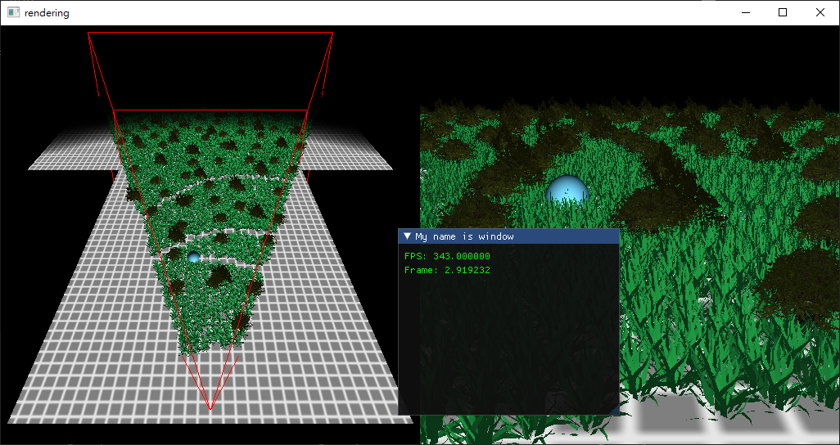

**initializeGL**

* Load three models and textures to corresponding VAOs and textureId
* Load instance positions to vector<float> positions
* Load slime into VAO
* Create shader programs (grass/slime/reset/collect)
* Setup 3 ssbos
* Setup draw commands
* Bind 2nd ssbo onto model vao 3rd attribute

**paintGL**

* Dispatch reset program
* Set uniforms and Dispatch collect program
* Use grass program
  + Set uniforms as god and draw with left viewport (glMultiDrawElementsIndirect)
  + Set uniforms as player and draw with right viewport (glMultiDrawElementsIndirect)
* Use slime program and set slime position with model matrix
  + Set uniforms as god and draw with left viewport (glDrawElements)
  + Set uniforms as player and draw with right viewport (glDrawElements)

**mouseButtonCallback**

setup mouseClick = true when holding down mouse button

set firstMouse = true when release mouse button

**cursorPosCallback**

when mouseClick = true, calculate mouse movement and update pitch and yaw to update godViewMat

**keyCallback**

when wasd is pressed, update playerCenter and playerPosition

Update playerViewMat, godViewMat, godPosition

**IDE**

Visual studio 2017 / C++14